Component Tracker:

Module: Programming Fundamentals-DN4MD0011-25/26

Name: Nishan Singh

Lecturer: Dr Graham Burvill

Student ID: 30259113

1.Objective
The objective of this project is to produce a piece of software for Wyre Systems Group (WSG), a UK-based engineering organization, specialising in high-integrity software and embedded tools used across aviation, transport, and autonomous monitoring systems. The software will allow engineers to record component status updates, maintain operational logs, monitor quantities, and flag replenishment requirements.

Scope of project
Features included in the project:
- GUI (Graphical User Interface).
- Component tracking system with CSV database.
- Add, remove, search and logs buttons.
- Logs Window
- Component status field
- Security implementation
Features excluded from the project due to restraints:
- Database on cloud Storage.
- Exportable Data.
- Support for multiple concurrent users.

Resources
Software | Hardware | Libraries
Python | Personal Computer | CSV
CSV Module |  | Pygame or Tkinter
VS Code |  | HashLib

Timeline
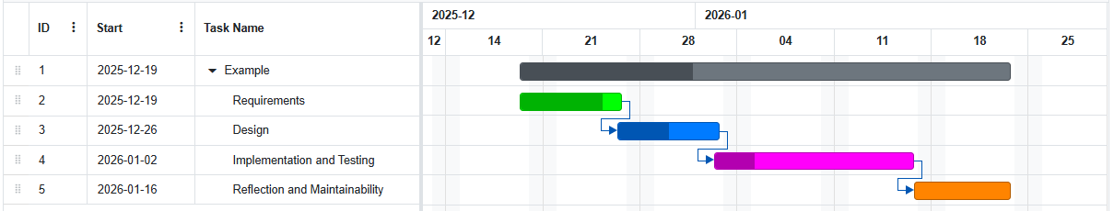
Figure 1: Gantt Chart Timeline of Project

Requirements
This software is for WSG, they require a functional and secure component tracking tool. The system must allow staff to add view and update data whilst flagging replenishment requirements with clear visibility for all engineers. It should also include a method to validate the user’s authority. Therefore, an intuitive and functional interface is required for users to understand how to use the software without much training, whilst it also remaining safe and efficient to use. With this information, we can produce the following requirements.
Functional Requirements:
- Login system requiring username and password. (Security) – Acceptance Criteria: Strip inputs and passwords should be encrypted as a supplementary feature.
- GUI. (Interface) – Acceptance Criteria: Using Tkinter to have functional windows
- Displays inventory data in a structured table view. (Interface) – Acceptance Criteria: Table updates after every action.
- Add new components. (Functional) – Acceptance Criteria: Make sure data is inputted correctly before adding item.
- Remove components. (Functional) – Acceptance Criteria: Removes component shows a confirmation message.
- Search components. (Functional) – Acceptance Criteria: Allows searching by SKU and displays only the item with the given SKU
- Error handling where needed. (Security) - Acceptance Criteria: Rejects input failures and prompts user to re-input data without stopping code.
- Logs Window. (Functional) - Acceptance Criteria: Shows actions taken and the timestamp it occurred.
- Low stock reminder (Functional) - Acceptance Criteria: Shows that stock quantity is low.

Non-Functional Requirements:
- Intuitive interface for engineers. (Usability)
- Responsive and reliable. (Usability)
- CSV file-based data storing. (Feature)
- Code should be maintainable. (Usability)
- Logs should be clear and concise. (Usability)

2. Design

Methodology
For the component system, there is the option to use either agile or waterfall methodologies. However, I have chosen to adopt a waterfall methodology. As stated by Bogdan, waterfall is better suited for small projects with strict requirements that are not subject to change, and that agile is better for continuous delivery and where requirements are not well defined or subject to change (Bogdan et al. 2019).

Programming Language
This will be programmed in Python. This is due to its readable and simple syntax, which will speed up development and debugging, given time constraints. Python also has a large selection of libraries which work well with this project, and it functions perfectly on Windows, MacOS and Linux.

Storage
For storing data, the program will use CSVs. CSVs helps avoid complex setups, while still allowing small-scale and local data storage. It is also readable by humans, so it can be debugged efficiently (Hart et al. 2016). This will also reduce the risk of someone breaching the code or revealing sensitive data that has been hard coded. This system will use “username, password” columns for the login CSV and for the inventory it will use “Component, SKU, quantity, status”.

Security
Although not mandatory, I will be hashing all passwords that are saved to the CSV file. This way, if anyone who shouldn’t be able to is able to access the login details, they will not be able to use them. I will be hashing them using the hashlib library and SHA256 (Python, 2024). This is because it is also native to python and is both effective and efficient to implement.

Graphical User Interface (GUI)
Tkinter will be used for the GUI and is especially designed for regular GUIs, unlike alternatives like Pygame. It handles tasks like buttons, labels, and general layout, more efficiently. It has native support for Python, so no extra installations are needed. It can also integrate easily with csv databases using file handling, which is necessary for this project. It is also considered lightweight and easy to maintain. It was stated from Douglas that Tkinter was easy to use and has many tutorials available (Douglas et al. 2016). This makes it appropriate given the time constraints of the project.
Within Tkinter, there is Treeview, which allows data to be displayed in a structured table. This works well with my project, as a component tracking system needs to be clear and structured. It supports column headers and does not require external libraries. It is more efficient than plain text and provides a simple and minimalistic user-interface, to analyse multiple pieces of data at once.

Paradigms
Multiple paradigms will be utilised, combining object oriented, event-driven and structured programming. This will help to balance clarity, maintainability and usability. Structured will be used for control flow. Object-oriented programming will be used for encapsulation and event-driven will be used for a responsive GUI based on user interactions. This is better compared to a procedural approach as with procedural, maintainability reduces as complexity increases. A database driven framework was also unnecessary given the scope of the project. While object-oriented programming increases modularity, it increases complexity at the start. Event-driven can also complicate debugging due to being non-linear. Though these were mitigated through modular separation and complete error handling and validation.

Maintenance Logs
A key feature of this project is the maintenance logs which allow the actions whilst using the system to be tracked. I plan to add the timestamp, action and sku number for every action so that the usage can be backtracked. This is also essential for keeping track of the status of the stock. It will have 3 columns, being “Timestamp, Action, SKU”.

Git/GitHub
During development Git/GitHub will be used for version control to track changes and revert back to older versions if needed. It also provides a backup in the event of data loss or other failures. GitHub also enables collaboration with others and provides cloud storage. All these demonstrate professional development practices.

Meeting Requirements
Functional Requirements:
- Login system requiring username and password. – Using the Tkinter GUI , it will request a username and password, while showing a ‘*’ when typing the password for extra layer of security. It will then verify those details, and this will restrict user access

- GUI. – Tkinter will be used for the GUI.

- Displays inventory data in a structured table view. – This will be met using treeview widgets to display data in a table that refreshes every time there is an update to the database.

- Add new components. – There will be an ‘add’ button which requires fields to have inputs and then will add new component to the database. This will be shown in the GUI.

- Remove components. – There will be a ‘remove’ button that uses the SKU number to find a component with the same SKU and removes it from both the database and the screen.

- Search components. – There will be a ‘search’ button that will use the SKU number. This will display only the component in the database with the given SKU.

- Error handling where needed. – There will be a message when the user gives an incorrect input. This will allow them to input again without disrupting the program or crashing.

- Logs Window – It will open a new window which will display the logs.csv file in a structured table.

- Low stock reminder – Will show a low stock status when quantity is 5 or below.

Non-Functional Requirements:
- Intuitive interface for engineers– An interactive but minimal GUI.

- Responsive and reliable. – There will be a load inventory feature so after each action, it is loaded to the GUI. This allows the visible information to be up to date.

- CSV file-based data storage. – This will use CSV files to limit exposure to external risks. This will help to restrict access to information by keeping it separate.

- Code should be maintainable. – The code will be modular and split into classes. I will also use readable variable names and add comments to improve maintainability.

- Logs should be clear and concise. – The logs will only have 3 columns and update every time there is an action.

Flowcharts and Pseudocode
Overview of Inventory Management System:
See Appendix For:
- Login Pseudocode (20)
- Sketch of GUI (Figure 24 and 25)
- Login Flowchart (Figure 21)
- Class diagram (Figure 22)
- UpdateQuantity Flowchart (Figure 23)

3. Implementation Approach
The component tracking tool for WSG was developed in Python. The Tkinter library was used for the GUI and CSV files were used for local data handling and hashlib with SHA256 for encryption. The code follows a modular, object-oriented programming approach with both structured and event-driven paradigms.

Paradigms used
The system demonstrates the structured programming paradigm by utilising conditional branching with methods such as addItem(), removeItem() and updateQuantity(), to ensure that the control flow is predictable and reasonable (Python, 2026a). This allows for more efficient debugging.
It also uses a modular approach by using object-oriented programming. This allows the program to be split into separate classes such as InventoryManager, Component and Logger, which allows the testing of parts of the program individually and the reuse of components, improving reliability and maintenance (Python, 2026b). Not only that, but all file handling is also within InventoryManager which separates the logic from the GUI layer.
Lastly, it uses event-driven programming through a Tkinter GUI. This separates user interaction from the business logic so as buttons are pressed there are events which are generated that will execute the code further, which follows good software practices (Python, 2026c). These are all essential in high-integrity software engineering.

Modular Structure
Each class performs an individual role which reduces coupling throughout the project.
Each feature has been implemented as such, for example:
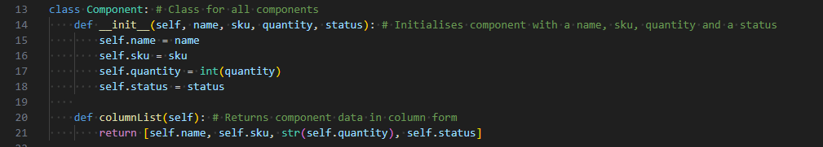
Figure 2: Class to make each component
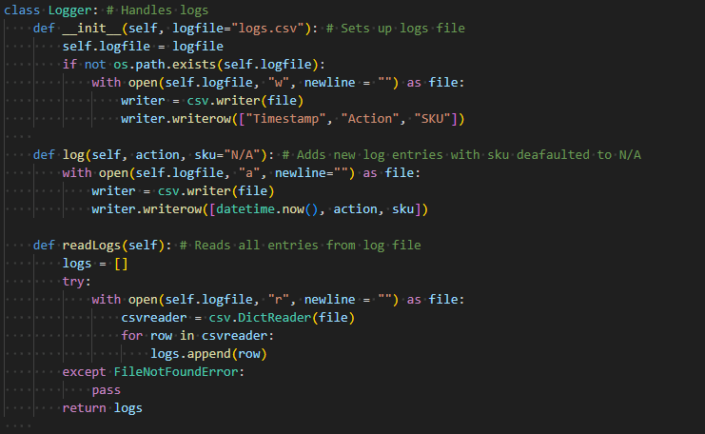
Figure 3: Class for the Logger
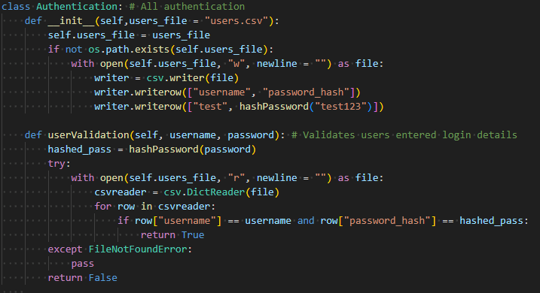
Figure 4: Hashed validation system

Algorithmic Complexity and Control Flow
The component control tool uses controlled flow to ensure predictable behaviour (Python, 2026a). Input validation is used before any progression as defensive mechanism for the code to prevent it from crashing. For example, addItem() retrieves an input and validates the type and range of the input (Python, 2020). Then it checks to see if the SKU is a duplicate and it will only add the new item if all the conditions are met. Returns are also used to prevent execution of code that could result in an error and the returns also help simplify the debugging process by separating functionality segments.
Decision branching is used to reduce unnecessary file writing and improve reliability overall. For example, updateQuantity() has multiple conditional branches such as SKU not existing, the new quantity being the same as the old quantity and if the quantity has changed. They all lead to different outcomes, and this ensures that redundant logs are not generated and the database remains consistent.
The operations for file handling include, searching, updating, writing and deleting and this operates with linear time, which is also known has a complexity of O(n) (Big-θ notation 2018). N represents the number of components in the csv and this is acceptable in this scenario due to the project being small in scale.

GUI
This code uses Tkinter widgets such as, Label, Entry and Button and they were used alongside Treeview to create the user interface.
- .grid( ) – This was used for the login form to align inputs.
- .pack() – This was used in the inventory window to simplify the layout.
- Treeview was used to produce the table in the inventory window.
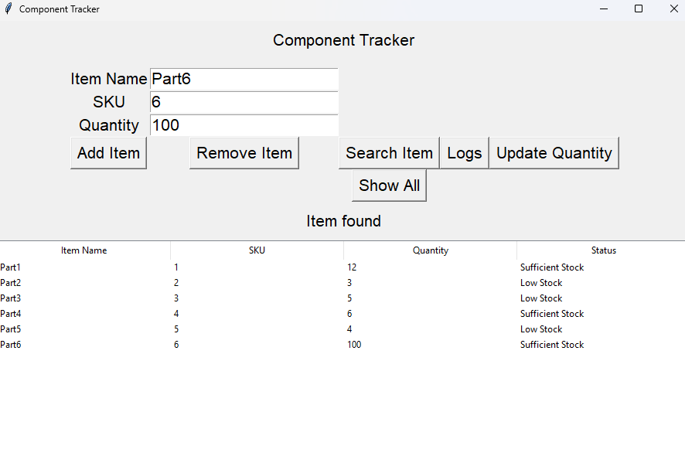
Figure 5: Component Tracker GUI

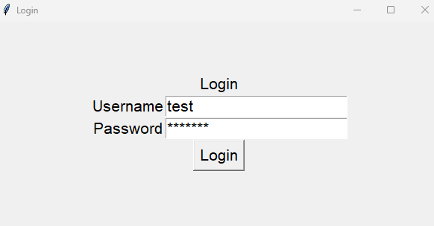
Figure 6: Login GUI

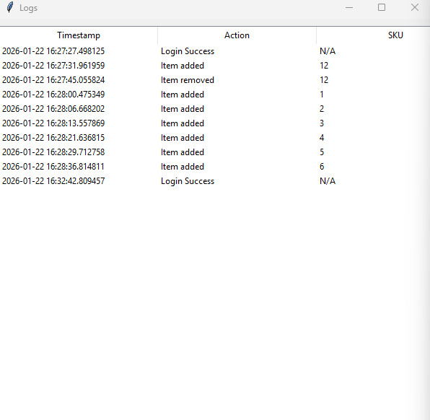
Figure 7: Logs GUI

Data Handling
CSV files were used to store data as it is readable, which made it easier to see what was happening to fix errors during development.

Error Handling and Validation
- To prevent incomplete fields from being inputted and the program crashing, input validation was implemented.
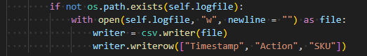
Figure 8: Creates new file if one doesn't exist

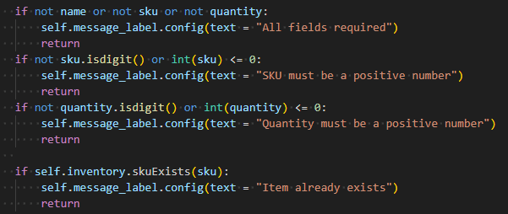
Figure 9: Input validation
- Messages were displayed in screen such as “Login Failed” or “Enter SKU to search” to prompt the user.

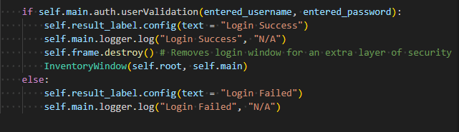
Figure 10: Login Failed message

Version Control
GitHub was used for version control and to store backups of the project. Commits were only made after significant changes, and this aligns with professional standards and practices.
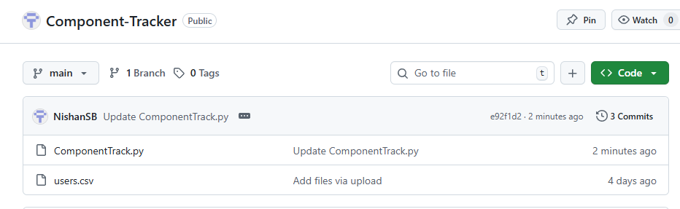
Figure 11: GitHub repository

Changes During Development
- Added “.strip()” to all inputs to prevent blank space issues.
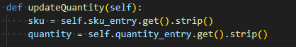
Figure 12: .strip()

- Centered login interface for usability.

Figure 13:Placed Frame for login in the centre of the window

- Adjusted font size as it was too small.

Figure 14: Adjusting font size to be more visible

4. Testing and Debugging Strategy
To test the system, black-box and white-box testing will be conducted. According to Verma in 2017, black-box testing tests the functionality as a user would where white-box testing tests the structure of the program (Verma et al. 2017). This meets professional standards as well as good testing practices.
See (Figure 26) for White-Box Testing
See (Figure 27) for Black-Box Testing
See (Figure 28) for Requirement Tracing

Fixes
I debugged the code using Python Debugger in the IDE VSCode (Visual Studio Code, 2026). This allowed me to run through the code step by step and use breakpoints to help debug efficiently. With this I could isolate the area with a problem and fix it.
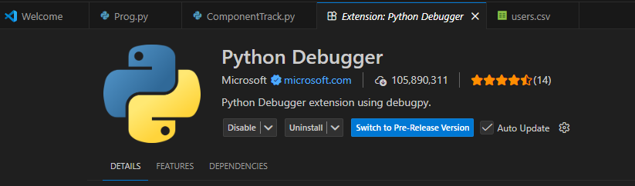
Figure 15: Python Debugger in VSCode
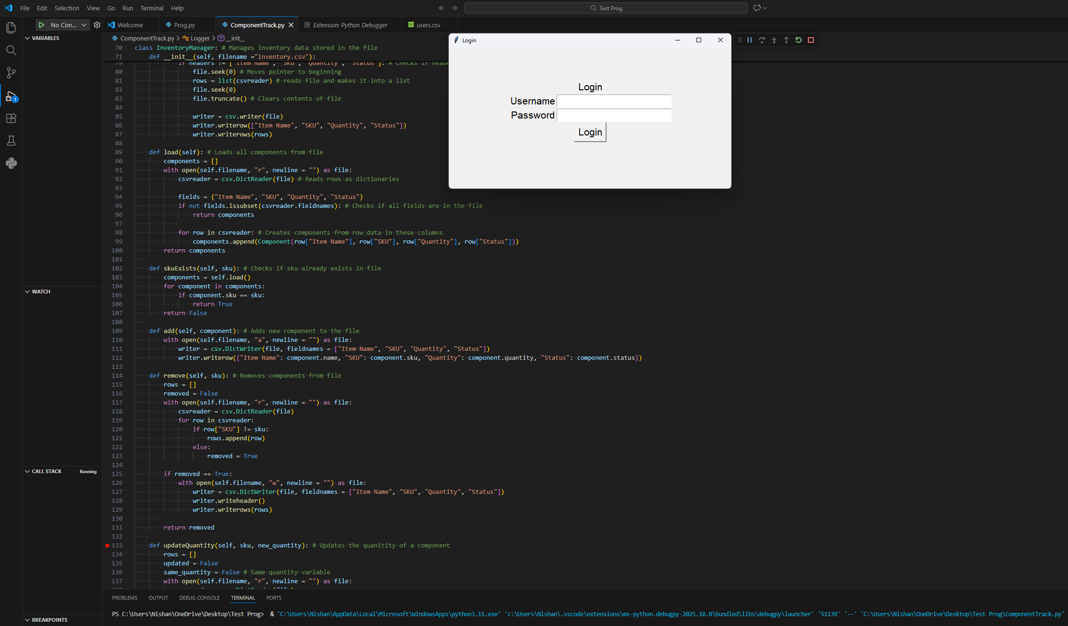
Figure 16: Using Python Debugger and Breakpoints in VScode
This does not show incomplete functionality as looking at the white box and black box testing, it is evident that there is an issue when updating to the logs file. Therefore, some changes need to be made to updateQuantity, so it does not update logs if the quantity is the same and instead display a message to tell the user that the quantity is the same. I have addressed the issues and demonstrated debugging and corrective measures.
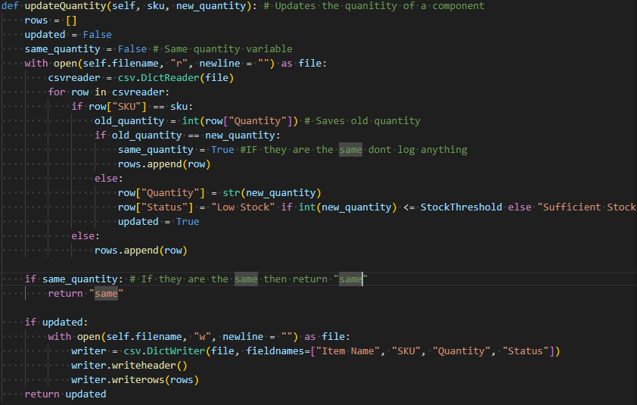
Figure 17: Inventory Manager: updateQuantity Fix
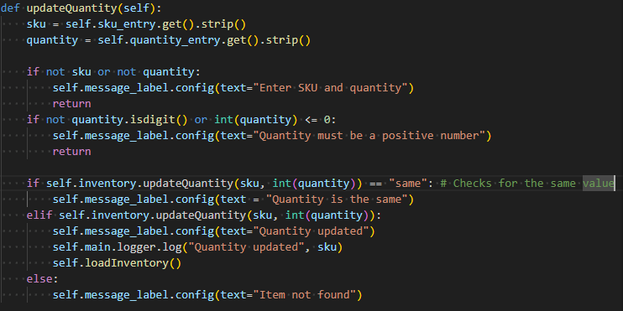
Figure 18: Inventory Window updateQuantity Fix
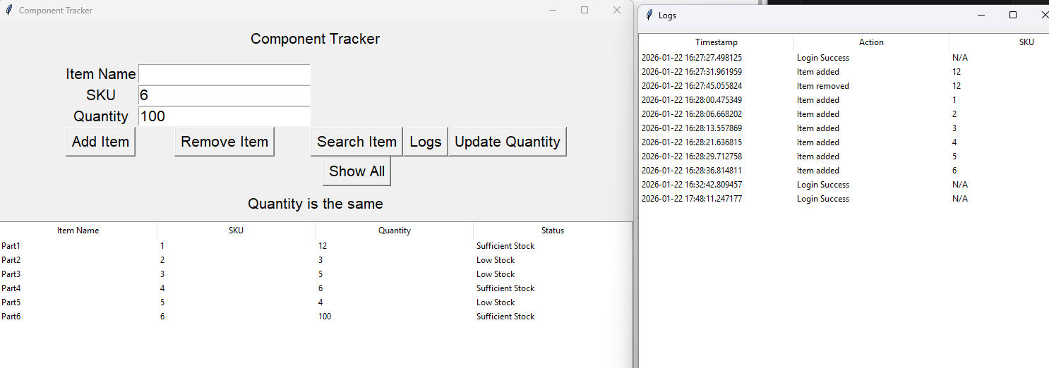
Figure 19: GUI shows code working

5. Reflection on Maintainability and Professional Standards
This project showed me the importance of following design decisions alongside the system requirements and learning outcomes. Writing modular, object-oriented code helped to improve maintainability and allowed for independent testing. A limitation of the implementation is the use of CSV files for storing data. While this method provides a level of transparency and clarity that is suitable for a project of this size, it is limited in capability. I believe that in the future, an SQL database would be more suitable, but it did not seem necessary for this project. Another challenge that was encountered was managing the control flow in an event-driven environment. It required careful validation and exception handling to prevent errors. If this was developed further, it could include access control, which allows access to different features depending on the user and automated testing such as unittest. Overall, the project deepened my understanding of programming paradigms, control flow and high integrity software engineering practices.

Appendix:

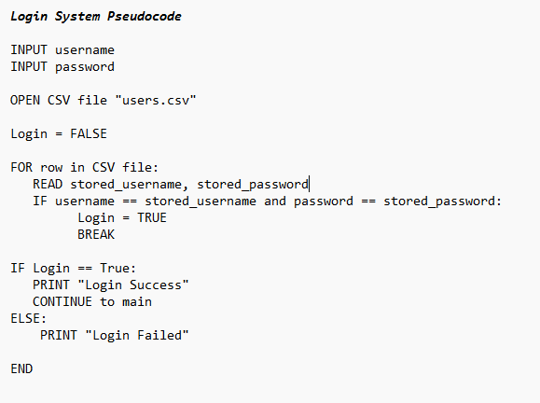
Figure 20: Login System Pseudocode

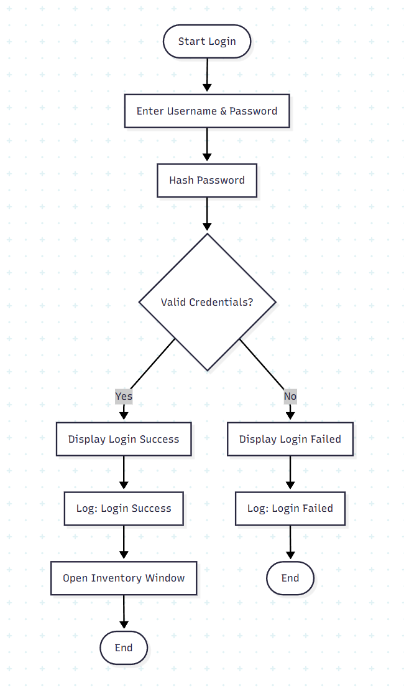
Figure 21: Login Flowchart

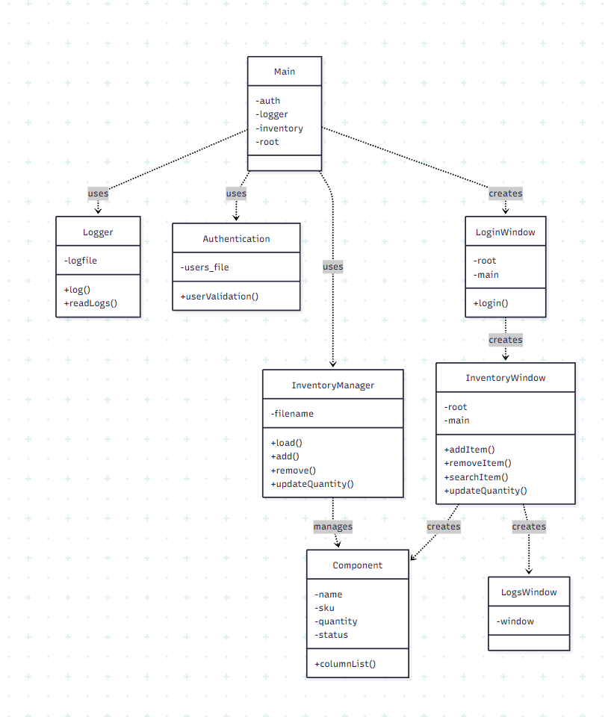
Figure 22: Class Diagram

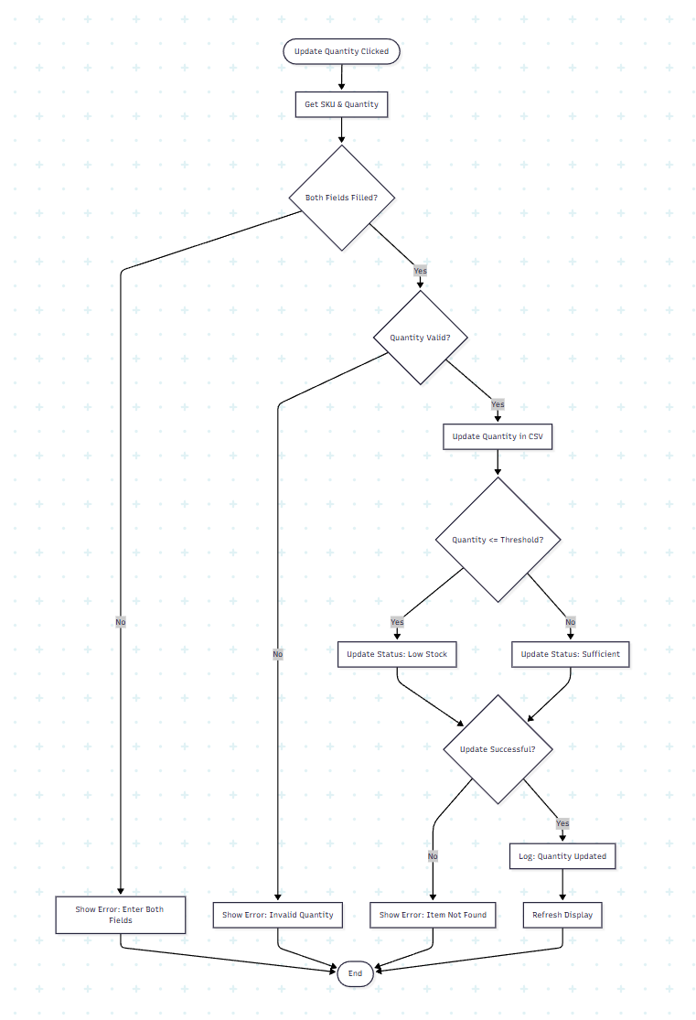
Figure 23: Flowchart of method to update quantity

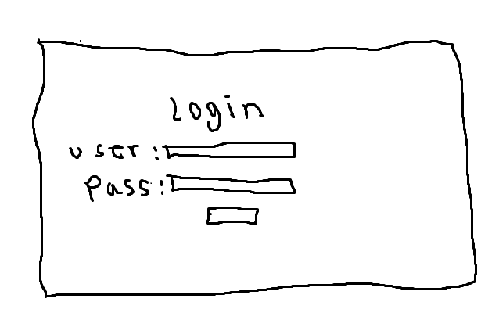
Figure 24: Login Window Sketch
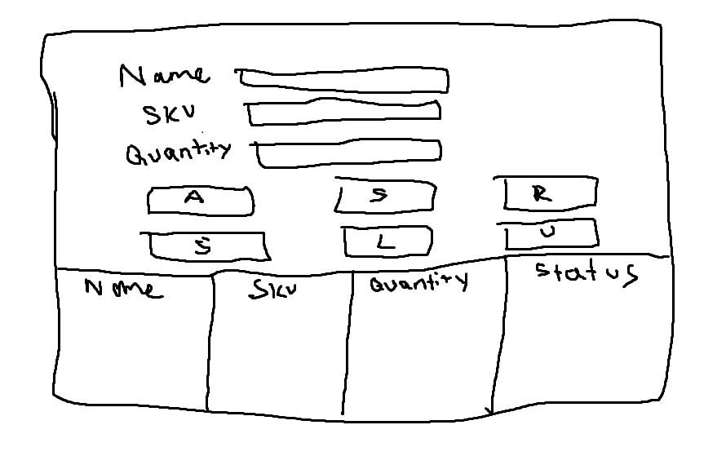
Figure 25: Main GUI Sketch
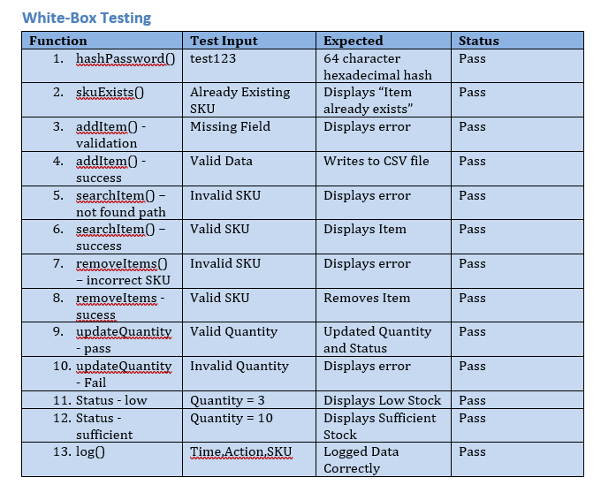
Figure 26: White-Box testing

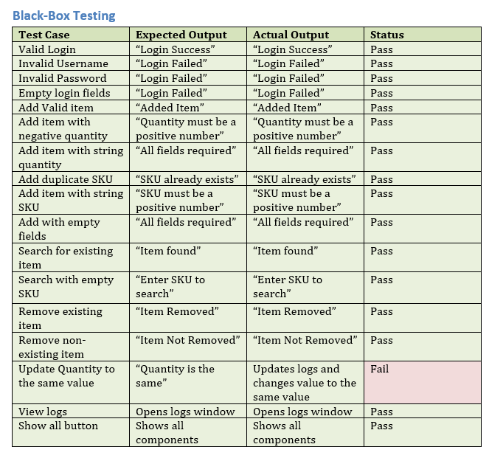
Figure 27: Black-Box Testing

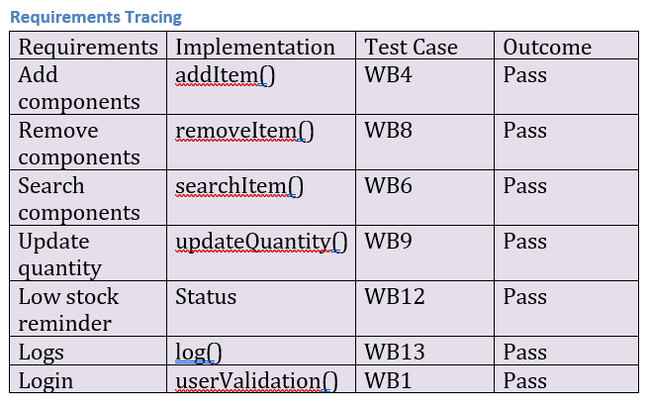
Figure 28: Requirements Tracing

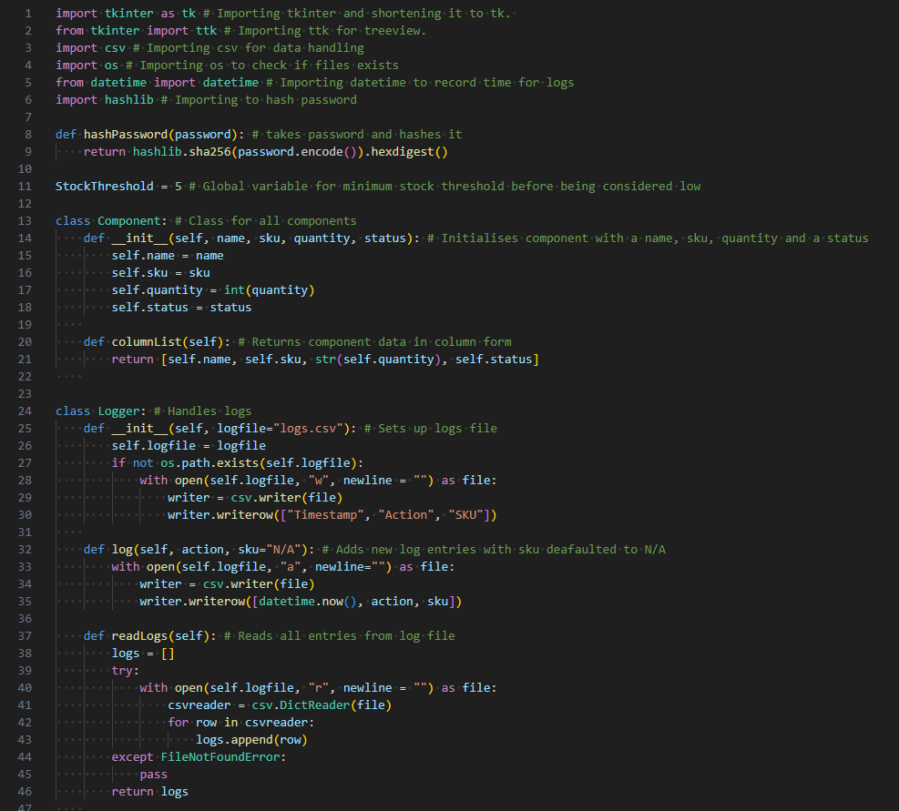
Figure 29: Source Code 1/7

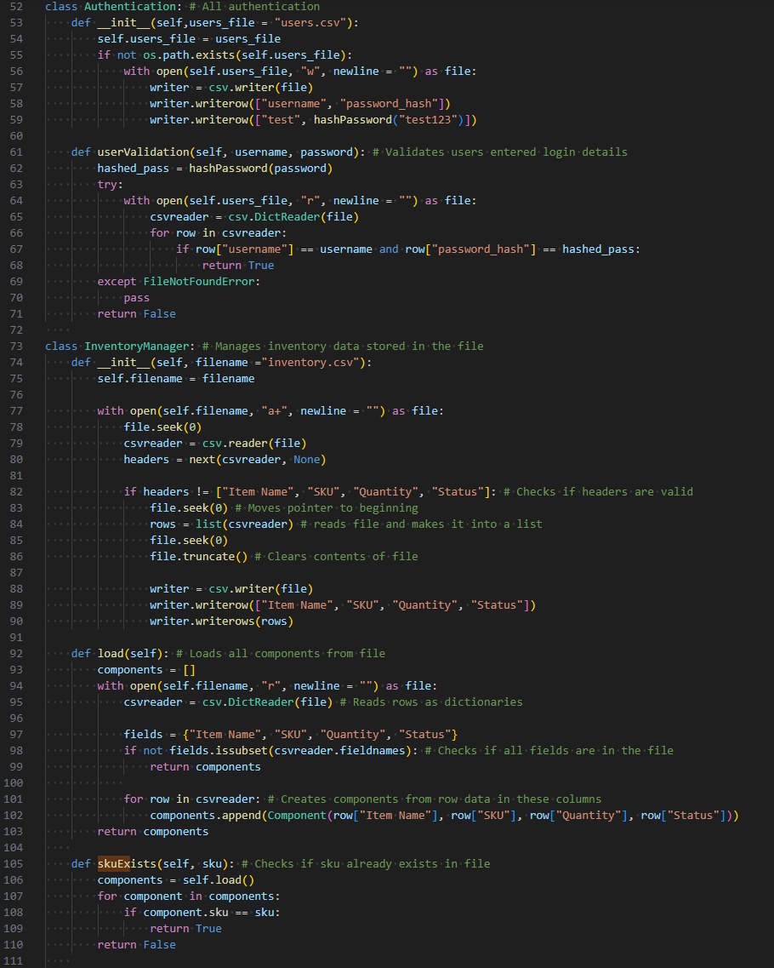
Figure 30: Source Code 2/7
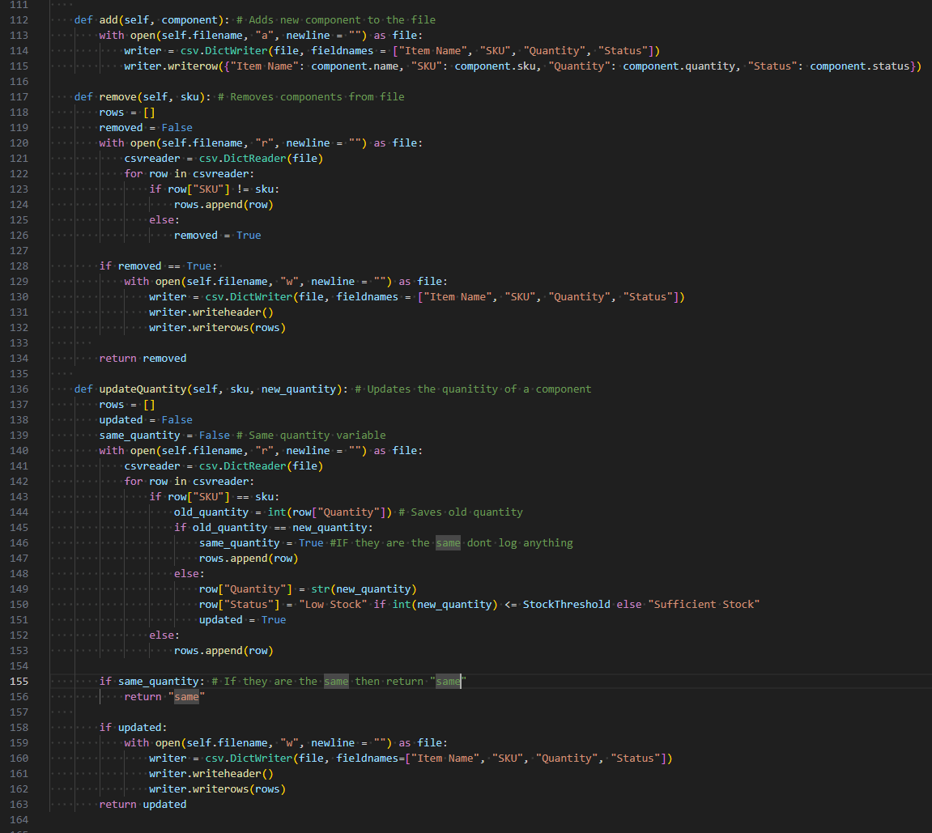
Figure 31: Source Code 3/7
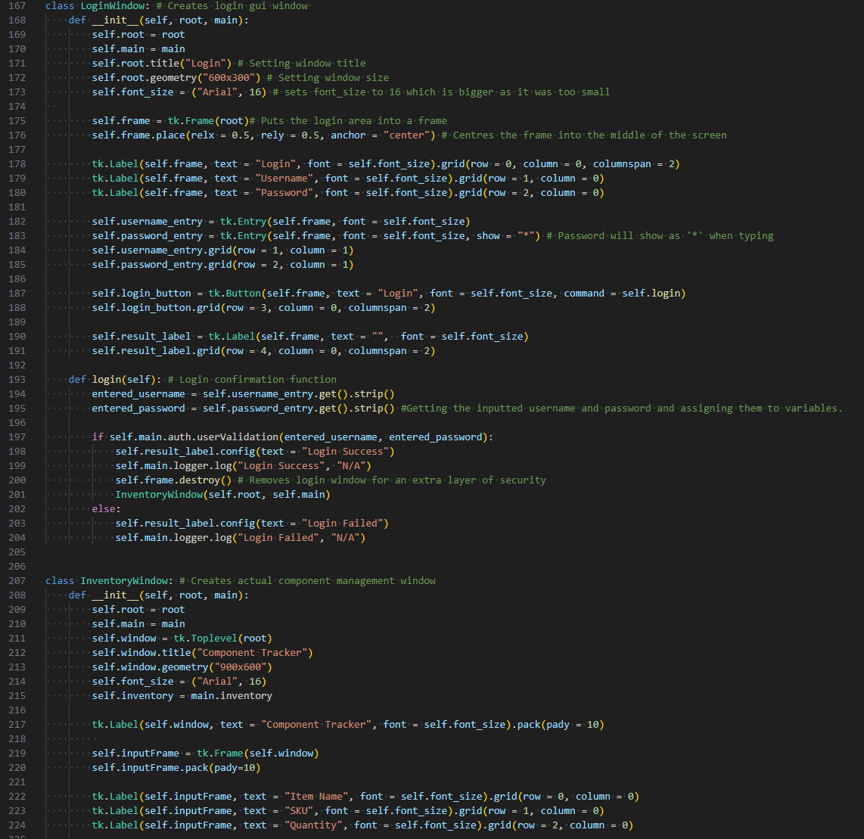
Figure 32: Source Code 4/7
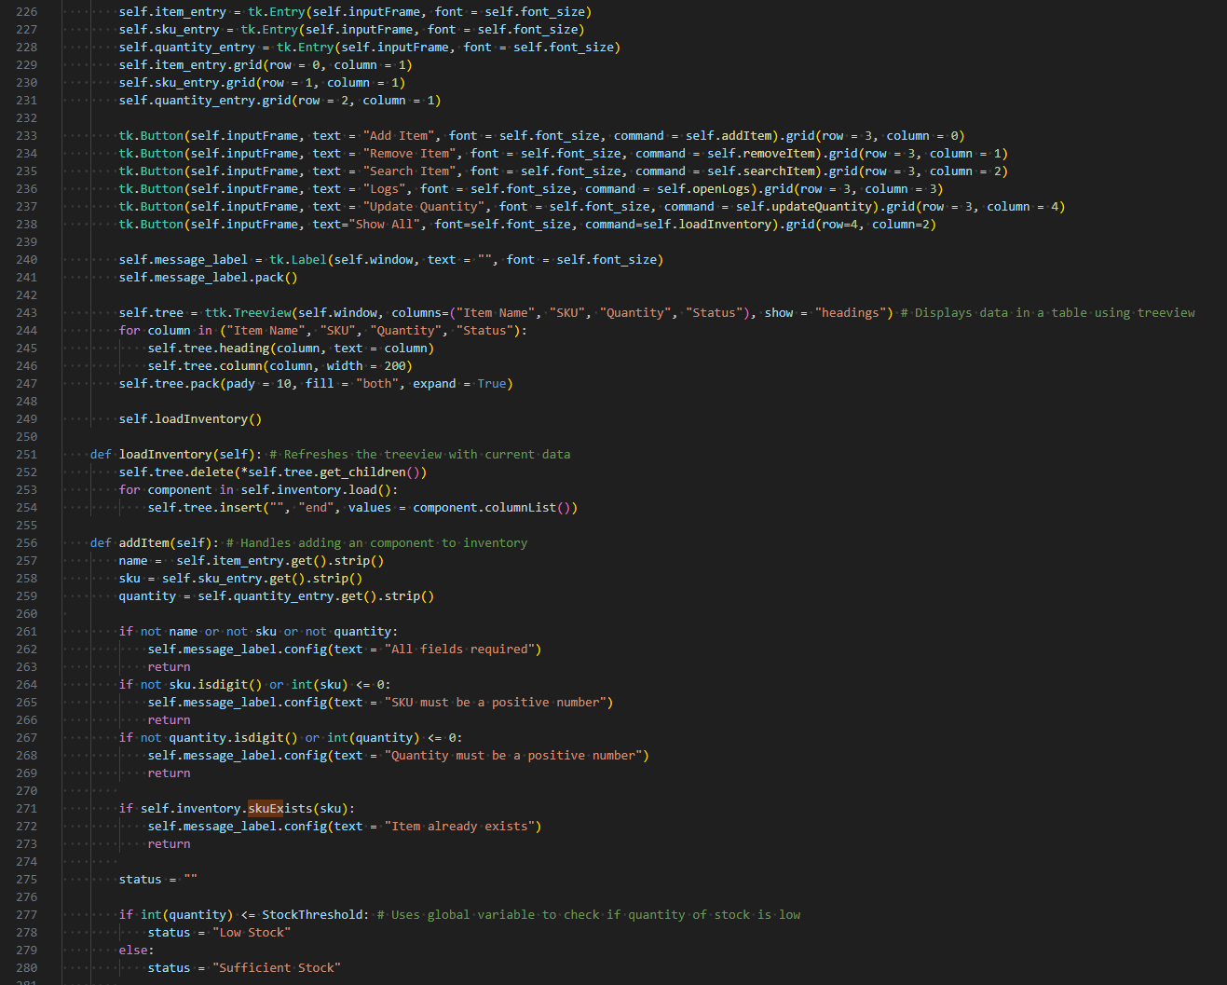
Figure 33: Source Code 5/7
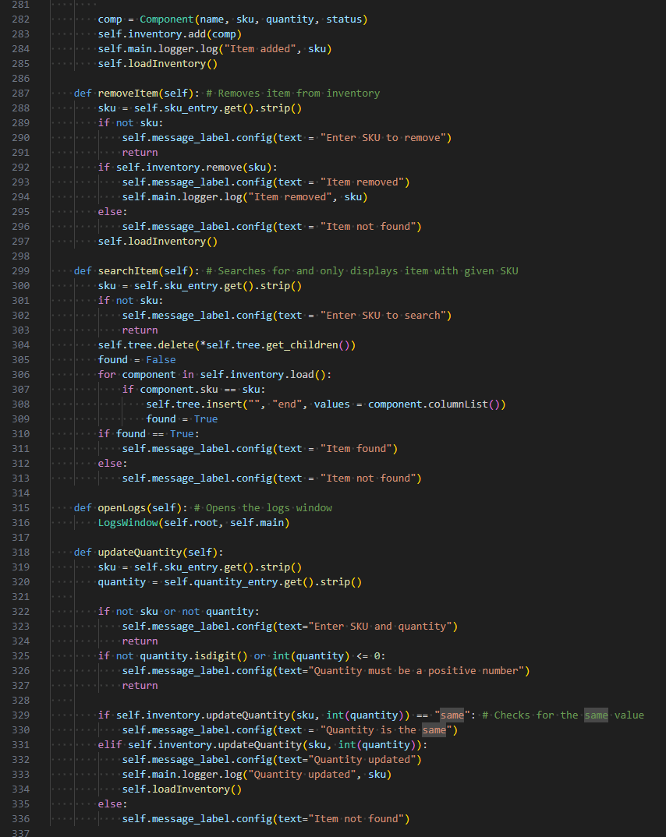
Figure 34: Source Code 6/7
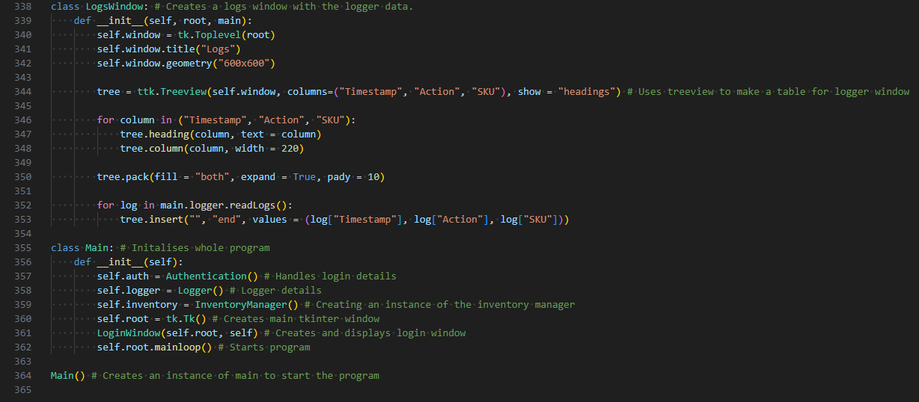
Figure 35: Source Code 7/7

GITHUB LINK : NishanSB/Component-Tracker

6. References

Bogdan, A. (2019). (PDF) A STUDY ON USING WATERFALL AND AGILE METHODS IN SOFTWARE PROJECT MANAGEMENT. [online] ResearchGate. Available at: https://www.researchgate.net/publication/333968900_A_STUDY_ON_USING_WATERFALL_AND_AGILE_METHODS_IN_SOFTWARE_PROJECT_MANAGEMENT.

Douglas Bezerra Beniz and Alexey Marques Espíndola (2016). USING TKINTER OF PYTHON TO CREATE GRAPHICAL USER INTERFACE (GUI) FOR SCRIPTS IN LNLS. [online] ResearchGate. Available at: https://www.researchgate.net/publication/320827237_USING_TKINTER_OF_PYTHON_TO_CREATE_GRAPHICAL_USER_INTERFACE_GUI_FOR_SCRIPTS_IN_LNLS.

Hart, E.M., Barmby, P., LeBauer, D., Michonneau, F., Mount, S., Mulrooney, P., Poisot, T., Woo, K.H., Zimmerman, N.B. and Hollister, J.W. (2016). Ten Simple Rules for Digital Data Storage. PLOS Computational Biology, [online] 12(10), p.e1005097. Available at: https://www.ncbi.nlm.nih.gov/pmc/articles/PMC5072699/.

NeuralNine (2021). Tkinter Beginner Course - Python GUI Development. YouTube. Available at: https://www.youtube.com/watch?v=ibf5cx221hk.

Tkinter Login Form tutorial for COMPLETE beginners [responsive layout]. (2022). YouTube. Available at: https://www.youtube.com/watch?v=MeMCBdnhvQs.

Verma, A., Khatana, A. and Chaudhary, S. (2017). A Comparative Study of Black Box Testing and White Box Testing. International Journal of Computer Sciences and Engineering, [online] 5(12), pp.301–304. Available at: https://www.researchgate.net/profile/Sarika-Chaudhary/publication/325816726_A_Comparative_Study_of_Black_Box_Testing_and_White_Box_Testing/links/5d289f29458515c11c2a99b6/A-Comparative-Study-of-Black-Box-Testing-and-White-Box-Testing.pdf.

w3resource. (2023). Python CSV file viewer with Tkinter. [online] Available at: https://www.w3resource.com/python-exercises/tkinter/python-tkinter-dialogs-and-file-handling-exercise-9.php.

www.youtube.com. (n.d.). Treeview - Python Tkinter GUI Tutorial #116. [online] Available at: https://www.youtube.com/watch?v=YTqDYmfccQU.
Python (2024). hashlib — Secure hashes and message digests — Python 3.8.4rc1 documentation. [online] docs.python.org. Available at: https://docs.python.org/3/library/hashlib.html.
Python (2026a). 4. More Control Flow Tools — Python 3.8.3 documentation. [online] docs.python.org. Available at: https://docs.python.org/3/tutorial/controlflow.html.
Python (2020). 8. Errors and Exceptions — Python 3.8.1 documentation. [online] Python.org. Available at: https://docs.python.org/3/tutorial/errors.html.
Python (2026b). 9. Classes — Python 3.8.4rc1 documentation. [online] docs.python.org. Available at: https://docs.python.org/3/tutorial/classes.html.
Python (2026c). tkinter — Python interface to Tcl/Tk. [online] Python documentation. Available at: https://docs.python.org/3/library/tkinter.html#events-and-bindings [Accessed 23 Jan. 2026].
Python Software Foundation (2020). csv — CSV File Reading and Writing — Python 3.8.1 documentation. [online] Python.org. Available at: https://docs.python.org/3/library/csv.html.
Big-θ notation (2018). Big-θ (Big-Theta) notation. [online] Khan Academy. Available at: https://www.khanacademy.org/computing/computer-science/algorithms/asymptotic-notation/a/big-big-theta-notation.
Visual Studio Code (2026). Debugging configurations for Python apps in Visual Studio Code. [online] code.visualstudio.com. Available at: https://code.visualstudio.com/docs/python/debugging.

